Link GitHub : <https://github.com/zaiueu/Kriptografi/blob/master/Tugas/Tugas2.py>

1. Subtitusi

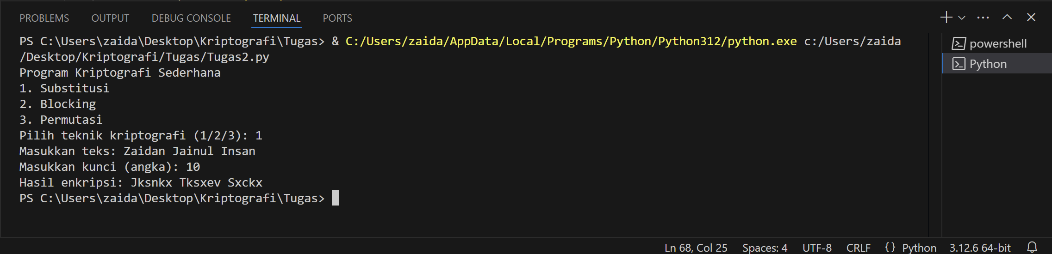

1. Blocking

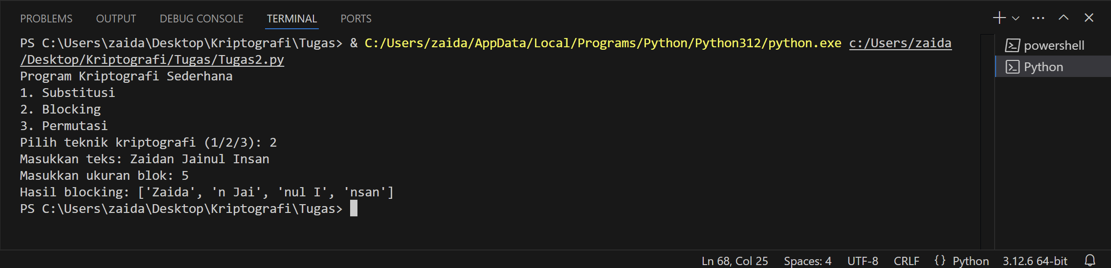

1. Permutasi

